Integration Tests

User Login

Purpose | The purpose of this test is to ensure that the user provided valid login details
Test Description | 1) Enter the login credentials  2) Send the login details to the web service.  3) Validate user results at the service end.
Expected Results | The user is navigated to the respective home page if the login details are correct.

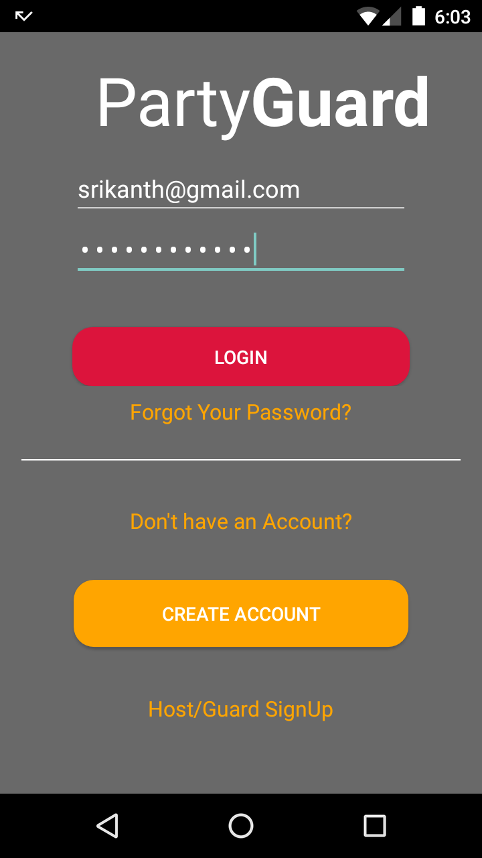

Login button is unable to function on the first click, so this is a failure.

User Sign Up
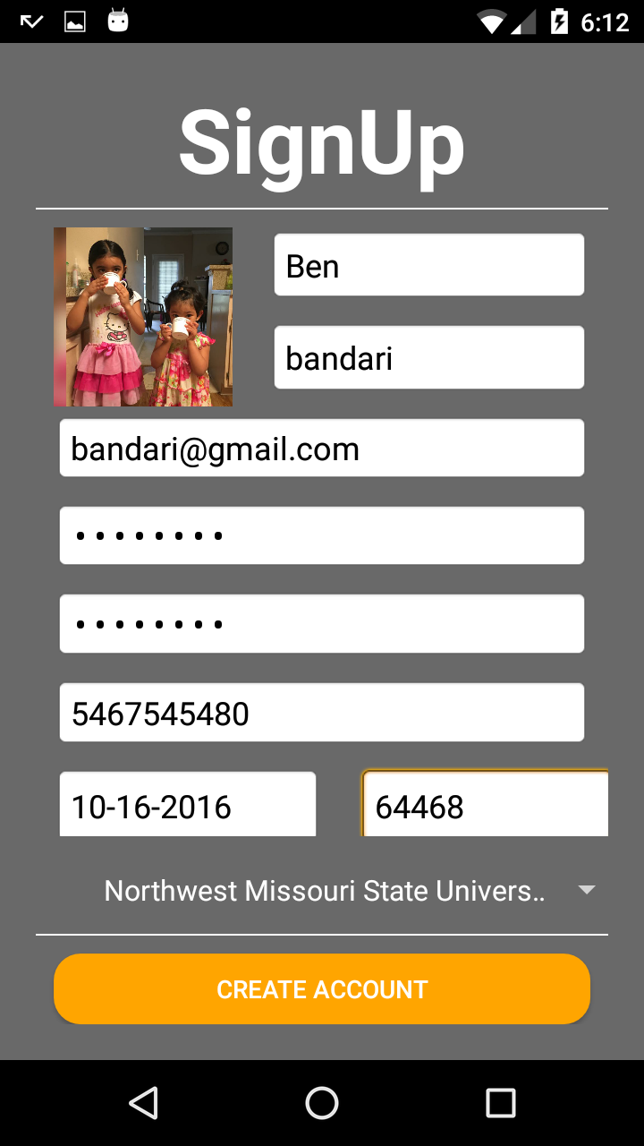

Purpose | Validate sign up details.
Test Description | 1) Enter all the required fields  2) Validate the details and post to the service.
Expected Results | If the sign up is successful, user is navigated back to the login page.

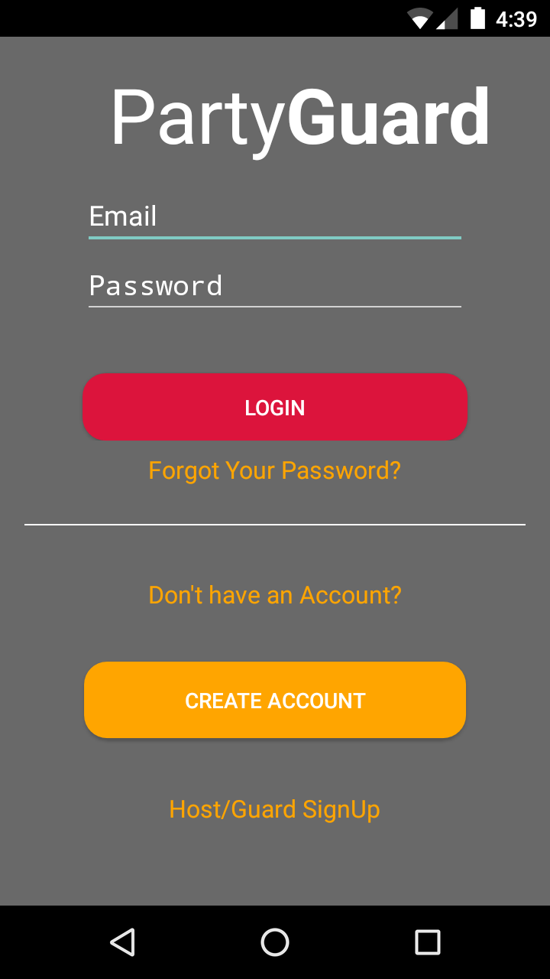

Forgot Password

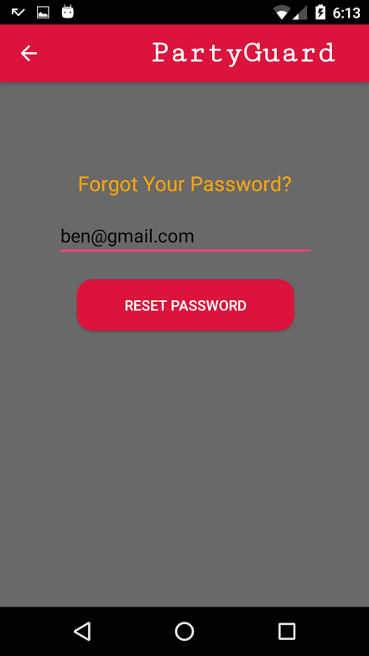

Purpose | Validate that user provided correct email
Test Description | 1) Provide the email provided during registration  2) Post the email to the service and validate the email.  3) Send a link to email to reset password.
Expected Results | The user is navigated back to the login page.

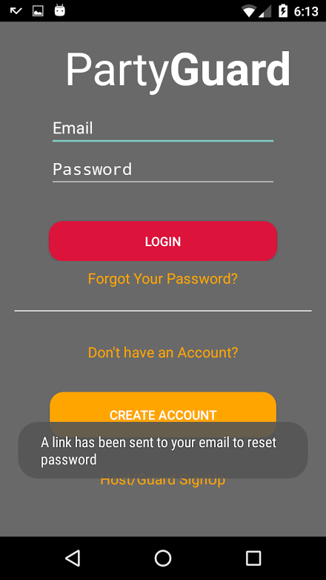

Choose University

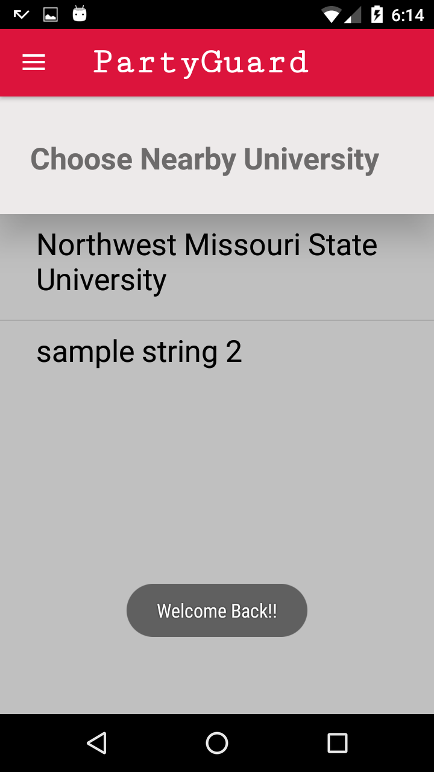

Purpose | Select a university from the list of universities provided.
Test Description | 1) All the universities provided in the service list are being displayed in the screen.
Expected Results | After selecting university screen, user is navigated to fraternity screen.

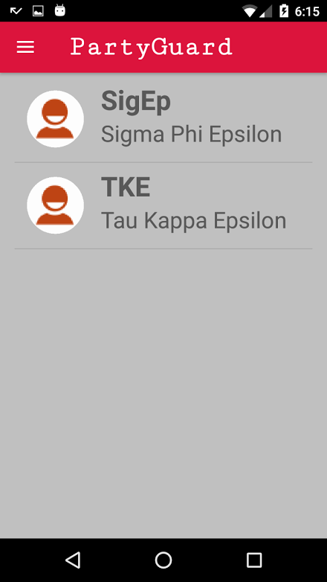

Profile Screen
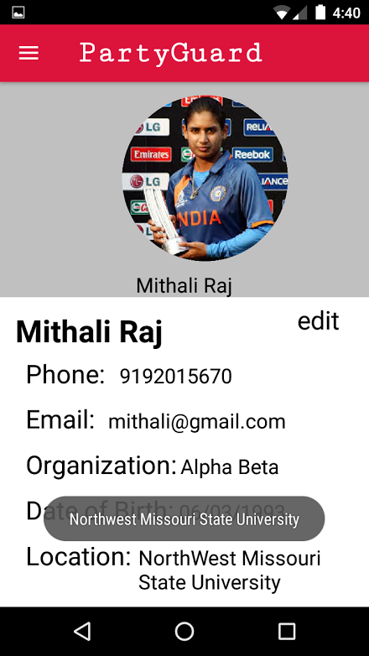

Purpose | User can view his profile and also edit the profile.
Test Description | 1) User can select any of the tab in the screen.  2) The data is fetched from the service and displayed in the screen.
Expected Results | All the edited details are posted to the service successfully.

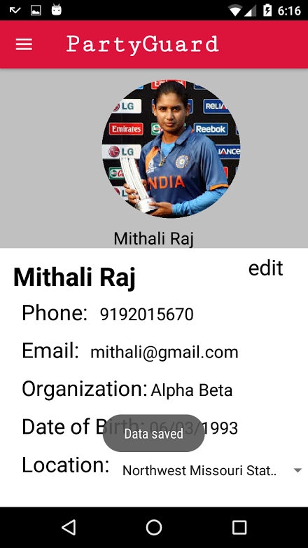

PG Team
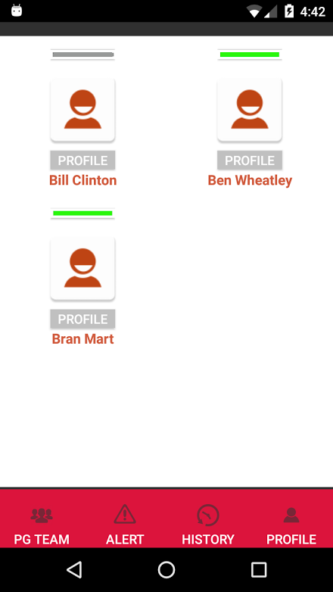

Purpose | All the guards in the fraternity are displayed in the screen.
Test Description | 1) Available guards are displayed with help of toggle bar.
Expected Results | By clicking on particular grid cell, guard profile can be viewed.

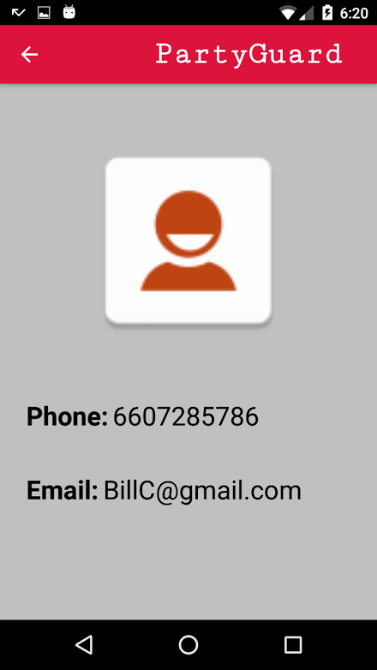

Alert Screen

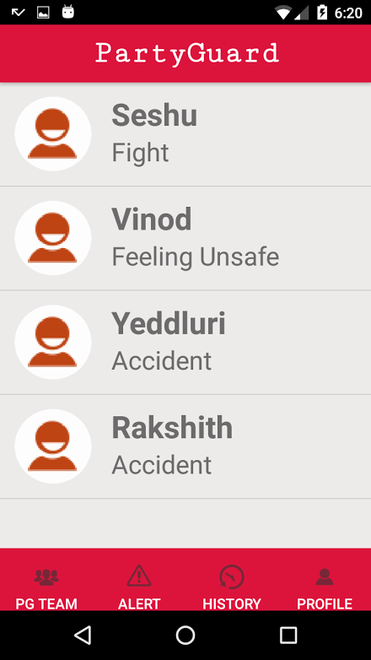

Purpose | All the alerts are displayed in this screen.
Test Description | 1) The alerts posted by basic user are added to this screen.
Expected Results | By clicking on a particular alert, alert details can be viewed. Host user can allot the guard in this screen.

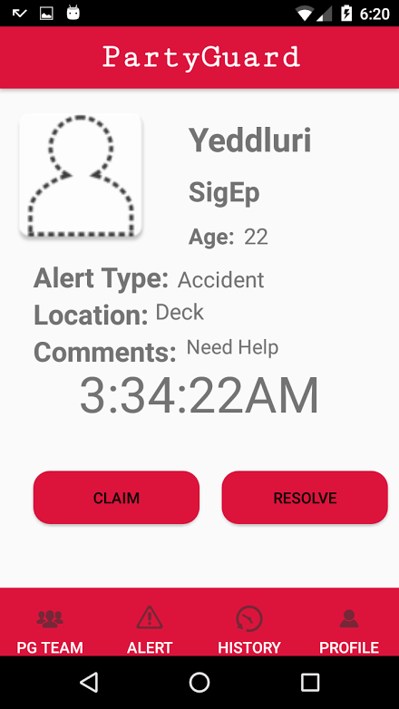

Profile Screen
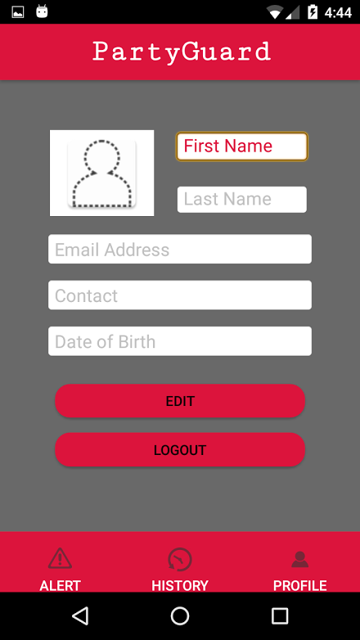

Purpose | User can view his profile and also edit the profile.
Test Description | 1) The data is fetched from the service and displayed in the screen.
Expected Results | All the edited details are posted to the service successfully and user can logout of the screen here.

